Ula Chowaniec
u.chowaniec@gmail.com

My Irenas Ideas of a Secular Jew: Irena Krzywicka, Irena Klepfisz
Language as a Tool, Ideas as a Medium/ or Inventing a Secular Jew?

I will start this short essay on a personal note. More than 10 years ago I devoted several years of my studies to the writing of a Polish writer, Irena Krzywicka (1899-1994). Even though, her Jewish origins were clearly important and influential to her as a human being, thinker and writer, I decided – in my close reading – to go along with her declared affinity and belonging – that is exclusively to Polish literature and culture. My “re-discovery” of this writer from the Interwar period, who was almost completely forgotten after WWII, was meant to be an emancipatory gesture: I wanted to bring her into the mainstream, and to certain degree I succeeded. Yet, this very successful, openly feminist and radical writer - by becoming a “Polish” writer - was somehow deprived of her Jewish origins and belonging. Although, Irena Krzywicka herself often expressed the wish that she not be treated as a Jewish woman and writer, as she was very much an assimilated Polish patriot and socialist, who wrote exclusively in Polish, I have very serious doubts now – as to whether my emancipatory gesture did not bear the characteristics of mainstream appropriation of her writings into the dominant culture.

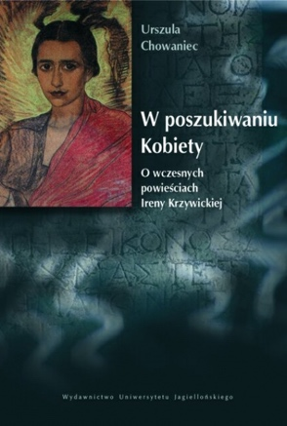
1 Ula Chowaniec's book about writings by Irena Krzywicka (2007)
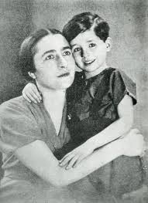
2 Irena Krzywicka and her son before WW2
In this essay I do not have the space to introduce the life and works of Irena Krzywicka, I am using her only as an excuse to talk about the possibility of discussing the theme of Jewishness in the case of a writer who is completely assimilated, who creates exclusively (and living) in the country’s language, and finally – who declares her belonging to the general culture and – in a way – dismisses her Jewish origins. How can we use the secular Jewish identity as a reading tool? Where can it be useful? How can it “open up” the text that hides its Jewish character (if it does)? These are the questions that are very important to me. And with these questions in mind, I wanted to present the Jewish “roots” of Irena Krzywicka, which are represented in the tradition of the Bund and to present The Bundist idea of Jewishness: the idea of a secular Jew. And finally, I will conclude with the figure of another Irena, Irena Klepfisz, the contemporary writer and poet, who is undoubtedly the poetic voice of the Bundist legacy on secularism and Jewishness.

How did we come to the Bund?
Irena Krzywicka was born in Yaniseysk, in Siberia (where the average February temperature is -18,8) where her parents had been sent for their socialist activities. Her mother Felicja Barbanel came from a completely Polonized family. She took her socialist passion from school, which she attended with Rose Luxemburg. When arrested she married her colleague, Stanisław Golberg, and they were both send to Siberia. There, Felicja Goldberg met Yekutiel Portnoy (1872-1941). It was the talks and the relationship with this crucial Polish Bund’s activist, which changed Felicja’s life forever: she not only became a life-time (in activism and romantic) partner of the leader of the Polish Bund, but also became a very devoted activist for the Jewish cause.
Even if, in her autobiography, Długie życie Gorszycielki (1994), Krzywicka refers to her mother’s activity and engagement in the Bund in a rather sceptical way, presenting her childhood as being haunted by the militia and the fear of being alone; however, there is no possibility that the socialist ideas of her home environment and the Bundist understanding of Jewish engagement did not affect her intellectually. The question of how and where we can find the echo of the Bund in Krzywicka – requires a complete re-reading of her writing, which I am planning to undertake, while taking into account the role of Yekutiel Portnoy in Polish history, the man that was Krzywicka’s father-in-law until his death in 1941.
Here – bearing in mind the complicated Polish -Jewish history - I would like to sketch a short history of the Polish Bund and to extract from it the idea of the socialist/secular Jew. Finally – to conclude – I will discuss secular Jewish identity in today’s America and analyse one poem.

Polish Workers Organisation BUND
General Jewish Labour Bund in Poland in the Interwar period was one of the most prominent Jewish organisations, engaging in the country’s politics. Bund was active in Poland throughout the interwar period and despite many internal conflicts and splits it sustained its social role as a leading secular and socialist movement within the Jewish community. The Polish Bund, which emerged from the General Jewish Labour Bund of Lithuania, Poland and Russia during the Russian empire that was created in Vilnius in 1897. The Bund had party structures, which were established among the Jewish communities throughout areas of the Russian empire. When Poland fell under German occupation in 1914, contact between the Bundists in Poland and the party headquarters in St. Petersburg became difficult. In November 1914 the Bund Central Committee appointed a separate Committee of Bund Organizations in Poland to run the party in Poland. Theoretically, the Bundists in Poland and Russia were members of the same party, but in practice the Polish Bundists operated as an independent party. In December 1917 the split was formalized, as the Polish Bundists held a clandestine meeting in Lublin and reconstituted themselves as a separate political party.
It is important to mention the Women’s Organisation of Bund, The Yidisher arbiter froy (YAF). I would like to reclaim the knowledge of this movement into cultural memory, because I find it very significant from the perspective of the development of second wave feminism, since many of the ideas of the late 1960s and the 1970s were present in the Bund’s women’s movement. The YAF was chaired by Sheyne-Feygh Szapiro Michalewicz (1887-1985), also known as Dina Blond, who was a very important figure in the sustaining of Yiddish culture in post-war America. It would be an exaggeration to claim that the women’s movement in the Polish Bund was an influential movement, yet it recognized the areas of social need that were neglected by many in the mainstream emancipatory movements. Among its main goals were:
1. Lifting the intellectual and moral position of its members;
2. Popularising community life among its members;
3. Providing the tools for entertainment during free times (libraries, reading rooms, courses, chorus, excursions, concerts etc).
Similar themes can definitely be found in all of Irena Krzywicka’s writing, for example. women’s initiatives were important in creating day-care (yasles), summer day-camps for children, raising the awareness of birth-control - such as through YAF’s involvement in creating Propaganda for Conscious Motherhood in 1932 in Warsaw (a centre for women, where, for example, Irena Krzywicka was actively involved).
The Bund has always focus on the improvement of the Jewish situation within the state of residency and the gaining of rights and possible full political and cultural emancipation. Even though the agreed official language was Yiddish, the official languages of the state were also accepted, hence the linguistic assimilation. However, this linguistic assimilation can also be seen as the creation of a new identity within the national languages: a language becomes a tool - the idea of appropriating language to Jewish aims. Bund, being a Jewish party, opposed assimilation within Polish society as well as the emigration of the Jewish population to Palestine. However, Bund did not exclude cooperation on the ideological level with Polish socialists. It demanded from the Polish State that the Jewish minority be granted broad autonomy. The means to realizing its ideas was the extensive agitation of the Jewish proletariat. The Bund was also an anti-religious party, seeking to secularize Jewish social life. It protested against the Jewish Religious Community, which was dominated by Orthodox and Zionists. I am certain that many Jewish/ Bundist themes can be found and one day will be found in my re-reading of Irena Krzywicka. Yet, someone who quite easily could have been Krzywicka’s daughther (or granddaughter), Irena Klepfisz (b. 1941) had to re-define the Bundist tradition and find her, own “post-holocaust” importance in the Bundist roots.

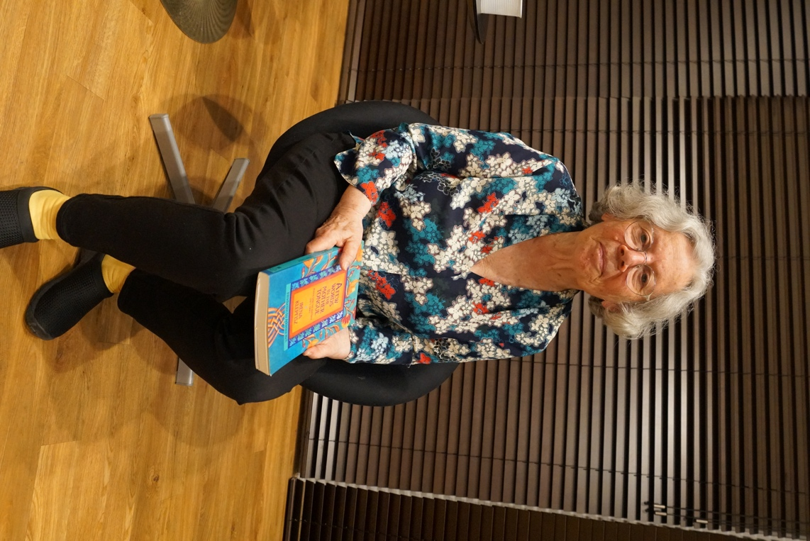
3 Irena Klepfisz in Stockholm 2019

Introduction: Who is Irena Klepfisz?
Irena Klepfisz is a poet, Yiddish translator, and teacher of Jewish Women Studies. She was born in 1941 in the Warsaw Ghetto. She was smuggled out of the Ghetto, hidden in a Catholic orphanage, and eventually survived the war by passing as a Polish child hidden in various families.
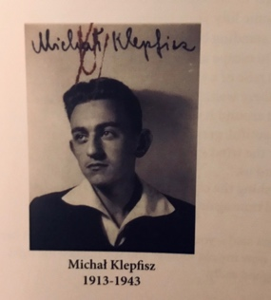
Figure 4The only photo of Michał Klepfisz, the Bundist leader
The Warsaw Ghetto Uprising, in April 1943 claimed the life of her father, Michał Klepfisz, a resistance fighter and a Bund activist who was posthumously awarded the Virtuti Militari medal. After the Warsaw Uprising (1944), she and her mother, Rosa Perczykow-Klepfisz, hid in a village until the liberation. They then moved to Łódź and, in 1946, emigrated to Sweden, and in 1949, to the United States.
In her The Secular Jewish Identity. Yidishkayt in America (1986) Irena Klepfish describes her understanding of Jewishness. Undoubtedly, it is a story of an Eastern-European Jew of Bundist tradition, it is a perspective of a woman, a daughter of a Bund hero, an heir of a secular pre-war radical tradition. What are the main points that Klepfisz stresses? First of all, Irena notices that for her, as young girl, a secular identity consists of the following “facts”, the BUND’s ideological secular standpoints:
- There is no God
- Capitalism oppresses the working masses
- The main goal is to work towards a classless society
- Jews have the right to be everywhere and they are not destined to return to their ancient homeland
- Yidish is the mame-loshn, the languages of the Jews “The medium through which Jewish culture and politics are to be transmitted” (Klepfisz 1990: 143)
These “facts” are enrooted in the Bund tradition of Irena’s upbringing (again, the word - upbringing is a complicated term here, because her early childhood development is torn apart by the Holocaust and the subsequent years of survival). Yet, I write these points as facts in inverted commas because they are full of contradictions, such as:
1. Firstly, the socialist politics of Bund, which Irena Kelpfish learnt in the USA was politics separated from its social contacts of the Eastern European pre-war context. (“For years, I thought every Yiddish-speaking adult was to be addressed as Khaver or khaverte (male or female comrade), I simply didn’t know the Yiddish equivalent of a plain “Mr.” and “Mrs.”” (Klepfisz 1990: 145);
2. The Jewish right to be everywhere had been cruelly denied during post-war antisemitism and in her own story and exile from Poland in 1946. This was further vividly realized during her first visit to Poland in 1983, when she experienced the lack of Jewish culture first-hand.
3. The third contradiction was the diminishing position of Yiddish in post-war history. Even her own attitude towards Yiddish forms this contradiction, since Yiddish was not her mome-loshn during the war, because as a child, in order to “pass” as Polish, the child Irena was encouraged to speak Polish exclusively.
4. And the next important new factor that changed the Bundist idea of Jewishness was the Holocaust. Undoubtedly, the Yiddish environment, the yidishe svive, Irena was part of, was affected by the “destruction”, “der khurbn”, and her whole childhood was marked by commemorating this tragedy. Those commemorations (with her as the daughter of a war hero) have been something that has influenced her enormously. Somehow the Bund pretended that the very core of ideology of the movement was not affected by The Holocaust.

These inconsistencies of the socialist, Bundist identity were juxtaposed by Irena Klepfisz with her university education in the 1950s and 1960s in New York, where there were no Jewish courses, no appreciation of Yiddish language, and where the treacherous and devastating experience of assimilation was imposed. Treacherous - because it was carried out with the seemingly positive intention of getting rid of social differences such as accents and habits; in this way assimilation could be seen as eliminating possible painful experiences by eradicating the cultural memory. Yet, this lack of memory returns and creates a void. And this is what Irena Klepfisz realized during her 1983 trip to Poland, and started to create a new language by introducing Yiddish into her English poetry, as she explains: “this fragmentary language, this echo of European era and culture in which I never lived and about which I only heard second-hand like a family story, this mame-loshn might prove worth salvaging and sheltering. …. I do know that when I have presented my poems at readings, when I have formed the sounds, said the words out loud, those who had assumed Yiddish was a language of the past only, suddenly felt it had been revived” (p. 143).

Yiddish languages in English poetry as a radical gesture.

Let’s look at one of the examples of this re-claiming of the forgotten mother tongue and reshaping it into a vehicle of new poetic identity in her bilingual poems:

Vider a mol/ Once again

Vider a mol
she tries to rise above circumstances.

Too much is at stake
this morning
yedn frimorgn
every morning
to see what can be wretched
from the unconscious
crowded darkness
fun ir zikorn
of her memory.

It is there
di gantse geshikhte
fun folk
The entire history
of the people.

Vider a mol
she reaches out
and tries to hold on
clinging
like a drowning
person
to a flimsy plank.

Ober der yam iz groys
but the sea is vast
und di velt
and the world
afile greser
even larger
afile greser.

This poem comes from the collection A Few Words in the Mother Tongue. New Poems (1983-1990). The collection of poems where Irena Klepfisz begins to juxtapose the English and Yiddish language together, in search of her own poetic voice and in order to express her own experience, and the experience of her generation. The best example of Irena Klepfisz’s journey to find her mother tongues is Di rayze aheym/The journey home. A cycle of 9 poems: 1. Der fenster/The window; 2. Vider a mol/Once again; 3. Zi flit/ She flies; 4 A beys-oylem/A cementery; 5. Kashes/ Questions; 6. Zi shemt zihk/ She is ashamed; 7. In der fremd/ Among strangers; 8. Di tsung/The tongue; 9. Di rayze aheym / The journey home.
All the poems here create one protagonist, a girl, a woman, a survivor. Here the Yiddish language is a symbol (or sound) of the lost world, and an anchor to the present world. The poetic persona of the poems, as in Vider a mol/ Once again, is perhaps the most identical to the poet herself out of all her writing. The poetic persona is a young girl who is lost between two languages and various foreign sounds: here we have a classroom situation where the teacher asks a pupil to repeat a sentence again, as she apparently has made a mistake, and this situation for an insecure girl is a near-death experience (like drowning Ober der yam iz groys…./ but the sea is vast). This experience of language confusion is emulated when the readers immediately feel confused because they do not understand the non-English words, as the poem is not directed towards a Yiddish-speaking audience. A displaced girl, who is lost in a foreign environment tries to survive (rise above circumstances), but her bewilderment seems to be increasing as if her lost dark memory is expanding into her immediate environment and the whole world. Taking into account Klepfisz’s biography and the fact that as a child she refused to talk publicly and at school she always remained silent, we can try to interpret these enlarged and irregular spaces between the words and verses in the poem as meaningful. Perhaps, the empty spaces and indentations are graphic representation of the girl’s/ “Irena Klepfisz” dramatic attempts to speak, her attempts, heavy breaths, perhaps tears?
The poem Vider a mol/Once again represents a poetic memory of Yiddish language and the lost world of Yiddish as recovered in American poetry, but Irena Klepfisz in her poetry also creates a figure of a contemporary woman, a secular Jewish woman, and this figure is another important feature of her poetry. It needs to be stressed that Klepfisz’s secular background of the Bundist tradition has not given her enough freedom, so she did not have to fight “her own” secular battles. Her own secular identity has to be expanded into the spheres that were important for her personally, and for many Jewish women, namely her lesbian identity and the fact that she was childless, which in the context of traditional culture always creates controversy. And this is where Klepfisz is at her most radical in her Jewish poetic voice: she is not only openly secular and reclaiming socialist secular tradition, she goes further, she knows that her Yiddish language is weak, never her own completely, so she re-claims it, but only partially and as part of her actual mother-tongue – English. Furthermore, her third radical step is her standpoint against the traditional sexual positioning of a woman and her role as a mother. Why and where is Klefisz radical? She is a (1) Secular, (2) Childless and Lesbian, (3) Bilingual poet/reclaiming Yiddish. And - here is the most interesting element of the contemporary dialectic of past/present, she is radical not by rejecting the past but by re-claiming and rediscovering the past, - the past of a socialist movement, of a Yiddish world, and the role of women in the Bundist tradition.
I hope one day to look for the Bund in Portnoy’s stepdaughter’s writing, Irena Krzywicka’s writing, and I am determined to find the role of Bund in Krzywicka’s worldviews, and by doing this I may find the meaning of the Bund in our contemporaneity.

Selected Bibliography:
Among the books, articles and websites I read while preparing this text are:
Klepfisz, Irena. (1990). A Few Words in My Mother Tongue. Poems Selected and new (1971-1990). Introduction by Adrienne Rich, Portland: The Eight Mountain Press.
Klepfisz, Irena. (1990). Dreams of An Insomniac: Jewish Feminist Essays, Speeches and Diatribes, Portland: The Eight Mountain Press.
Polonsky, Antony. (1997). “The Bund in Polish Political Life, 1935-1939”, in Mendelsohn, Ezra (ed.), Essential Papers on Jews and the Left, New York: New York University Press.
Opalski, Magdalena, Bartal, Israel (1992) Poles and Jews. A Failed Brotherhood, Hanover and London: Brandeis University Press.
Historia Bundu w Lublinie: http://teatrnn.pl/leksykon/artykuly/bund-socjalistyczny-powszechny-zydowski-zwiazek-robotniczy-bund-w-lublinie-w-dwudziestoleciu-miedzywojennym/#geneza-i-struktura-partii-bund (accessed: 12.02. 2020)

This draft of the article was written during the workshops led prof. Israel Bartal (in Jerusalem, January 2020 and Stockholm, February 2020)
My first article on Irena Krzywicka appeared in 2002, then I worked on and published about her in many post-conference volumes and finally my book on Krzywicka appeared in 2007, W poszukiwaniu Kobiety: o wczesnych powieściach Ireny Krzywickiej (Wydawnictwo Universytetu Jagiellońskiego, Kraków). Later on, her Interwar novel was reprinted (in edited vertion, Pierwsze krew, 2009), also books and an anthology by Agata Zawiszewska appered (Życie śwadome: o nowoczesnej prozie intelektualnej, 2010). So, in a way, Krzywicka became a generally well-known figure in the Polish literary milieu.
Just a fun fact, but also shows the dramatical start to her life https://en.wikipedia.org/wiki/Yeniseysk
“The Zweite Frauengymnasium was a school that only rarely accepted Polish applicants and acceptance of Jewish children was even more exceptional.” (see: https://en.wikipedia.org/wiki/Rosa_Luxemburg).
Pickhan G. (2001) Kossovsky, Portnoy and Others: the Role of Members of the Bund’s Founding Generation in the Interwar Polish Bund. In: Jacobs J. (eds) Jewish Politics in Eastern Europe: The Bund at 100. Palgrave Macmillan, London
Published after the death of Krzywicka and I never managed to find out whether Krzywcika approved the title. I suspect the editor of the autobiography and the Publisher used this catchy phrase rather than Krzywicka giving it this title herself.

