Jewish Women’s Writing

Anna Margolin (1887-1952)
Readings with Beila Engelhardt Titelman
(Paideia 21.09.2020)
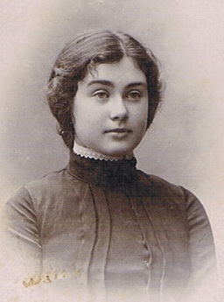
Rosa Lebensboim in 1903, she later published as Anna Margolin.
Critics claim she authored the finest Yiddish poetry of the early twentieth century
Book: Anna Margolin, Lider (1929), book in Yiddish: https://ia800302.us.archive.org/6/items/nybc208331/nybc208331.pdf

Translation into Swedish: Anna Margolin, Detta är natten, Ellerströms, transl. by Beila Engelhardt Titelman, 2018.

Short introduction from Hellerstein, Kathryn

﻿The Art of Sex Celia Dropkin and Anna Margolin

It is not surprising that Ezra Korman included poems by Celia Dropkin and Anna Margolin in his 1928 anthology, Yidishe dikhterins. Like their modernist contemporaries, the male poets of Di Yunge and Introspectivism, Dropkin and Margolin wrote poems that expressed individuality and aestheticism; shook off obligations to political ideology; and experimented with the disruption ﻿of language and form, influenced by Russian Acmeism and German modernism. But their writings differed from those by the men in that they advanced a new idea of poetry altogether—one that markedly announced the author as a sexual female. Like their contemporaries, Dropkin and Margolin chose to write in Yiddish, rather than in the non-Jewish languages of their European educations—Russian, German, or Polish—or in English, the language of their new home. This choice made sense in America, with its considerable Yiddish-speaking audience and press, Yet, although they rarely invoked traditional Jewish prayer, text, or custom, the frame of reference for the poetry of Dropkin and Margolin was as much Jewish as it was Western Civilization writ large, as much the Megillah as Rilke. The inherent Jewishness of the Yiddish language challenged these women modernists, alongside the men in the Yiddish literary avant-garde, to fashion poems that transcended culture and expressed the fragmentation and urgency of their moment. Both Dropkin and Margolin were among the very few women represented in the anthologies and miscellanies of the New York modernist movements, Di Yunge and Introspectivism. For example, Zishe Landau’s 1919 Yunge anthology included one poem by Celia Dropkin as well as one by Fradl Shtok.
Following the example of Landau’s 1919 collection of distinctive modernist poems, Anna Margolin edited a slender anthology, Dos yidishe lid in amerike—1923 (The Yiddish Poem in America), which she described as a collection “not of poets, but of poems . . . the best of the year.” Margolin’s collection included (out of twenty-two poets and forty-three poems) only two poems by women—Celia Dropkin’s “Di royte blum” (The Red Flower) and Malka Lee’s “Shtoyb” (Dust)—and, oddly, omitted her own work.
In his substantial 1927 Modern Yiddish Poetry: An Anthology, Samuel J. Imber sought to “offer to those uninformed or misinformed a glimpse of the modern poetical works of Yiddish literature, a literature hidden from them by the barriers of the Hebrew alphabet and by the slight strangeness of the misjudged language of the ghetto.” In this effort to enlighten an English-literate American audience, Imber presented transliterated Yiddish texts and prose translations of 166 poems by 77 poets, including 8 poems by 5 women—Celia Dropkin, Rokhl Korn, Anna Margolin, Fradl Shtok, and Miriam Ulinover.
But as of 1928, when Korman’s anthology went to press, neither Dropkin nor Margolin had published a volume of her own poetry. In this chapter, I argue that the rebellious, apparently non-Jewish poetry of Dropkin and Margolin can be seen to advance a specific idea of Yiddish literary tradition and the place of a woman poet within it. Dropkin’s poems challenged the cultural ideas that women should be tsniesdik (modest) and that their sexual purpose was reproductive. Placing an unbridled female sexuality at the center of her poems, Dropkin suggested that within it lay a woman poet’s creative powers. Margolin, in turn, challenged the notion that a woman poet was subject to a narrowly defined cultural Jewishness through her sexualized vocabulary of paganism and Christianity. In different ways, both Dropkin and Margolin took to task the notions of what Yiddish poetry should be and how women poets should write. To clarify, in the following discussion I do not assume that the poetry of Dropkin and Margolin is literally autobiographical. Rather, through my readings, I argue that within each collection of poems lies a submerged narrative about the figure of a woman poet.

Source: Hellerstein, Kathryn. A Question of Tradition (Stanford Studies in Jewish History and Culture) (p. 243- 244). Stanford University Press.

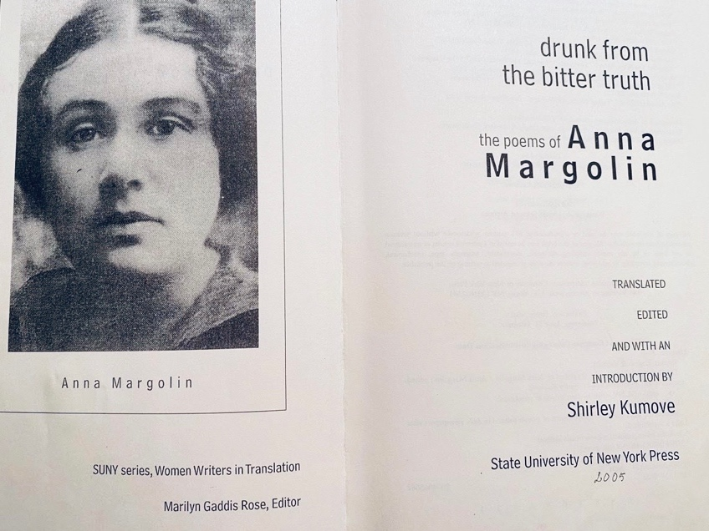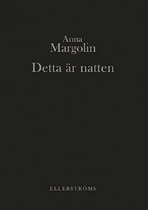

1).
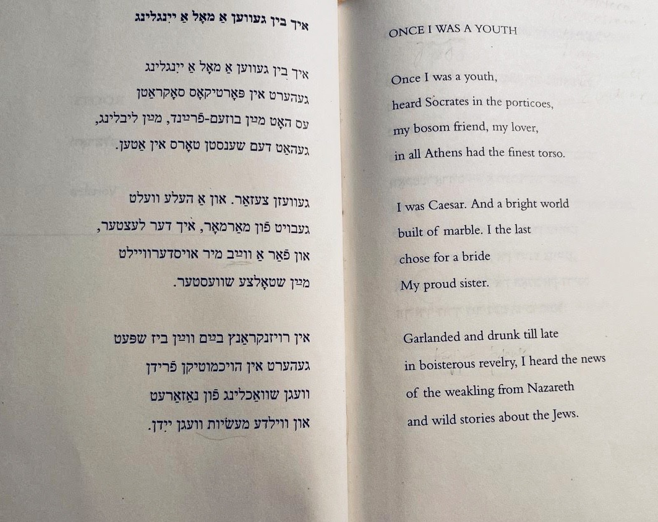

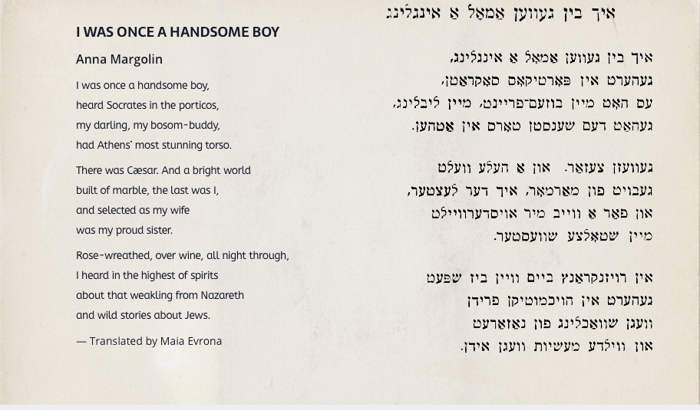

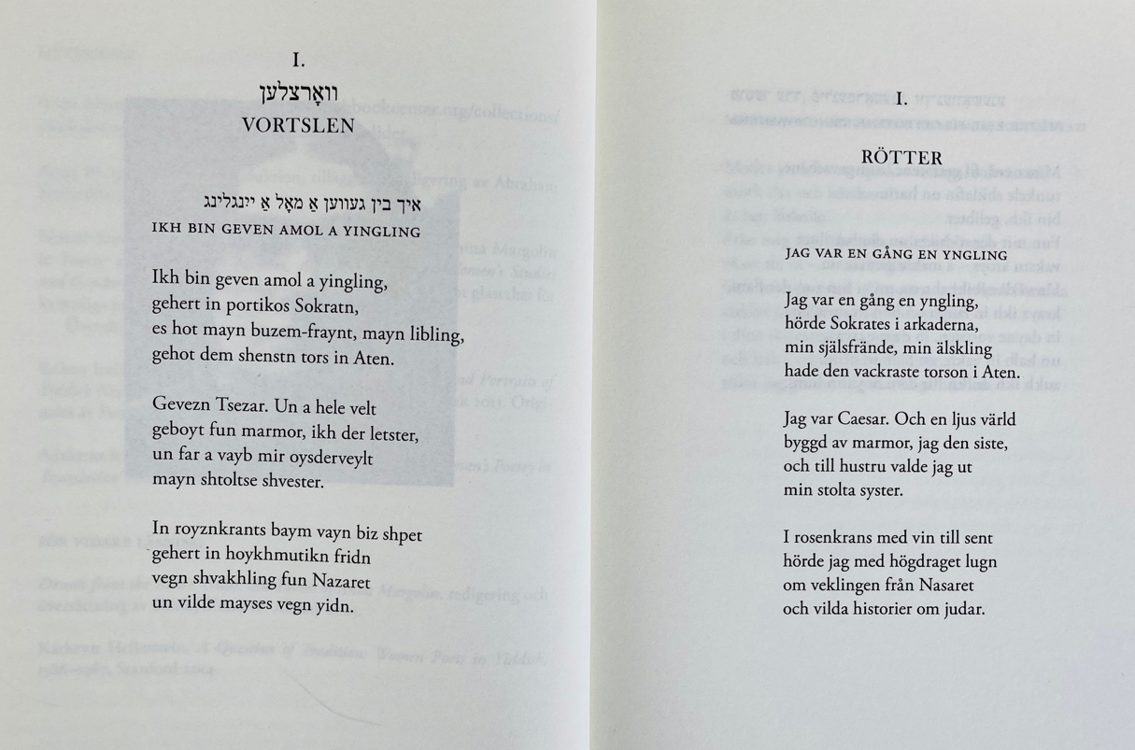

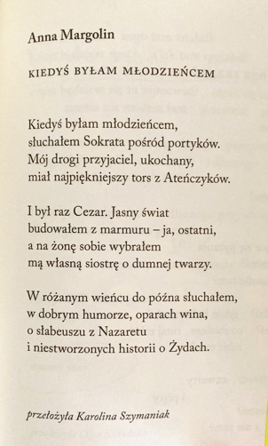

2).
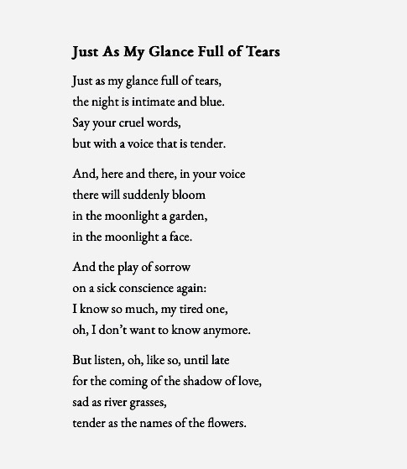

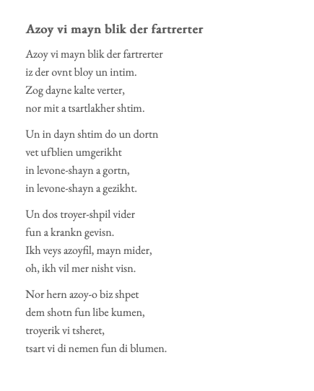

3).

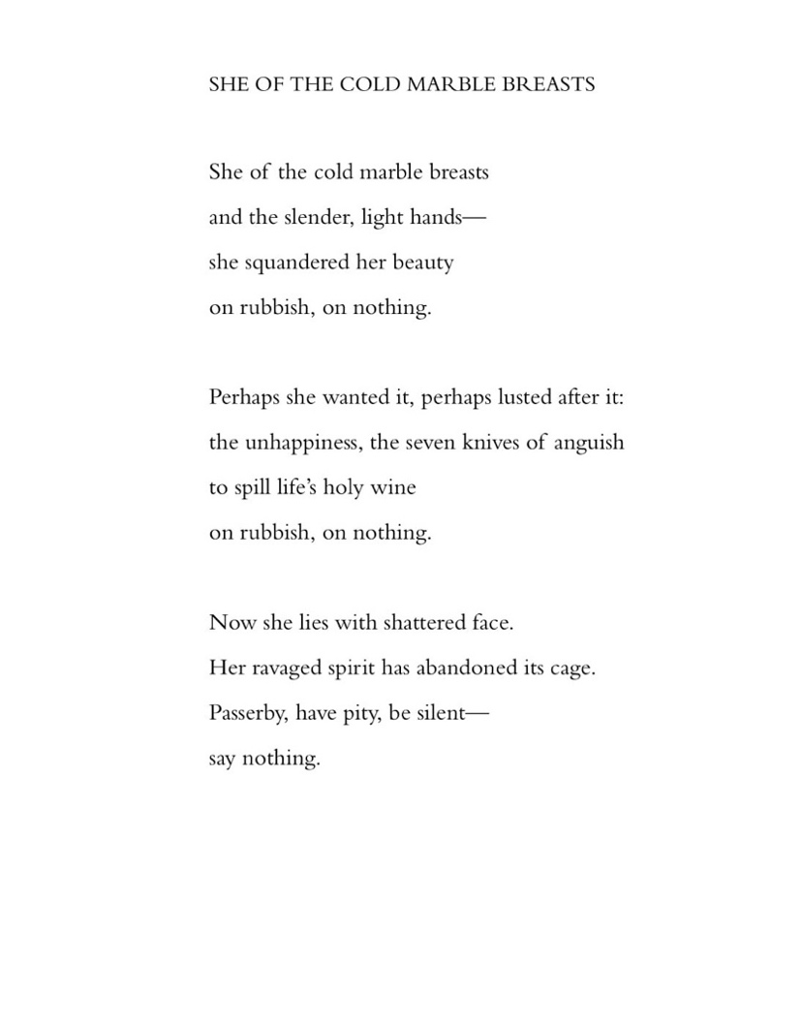
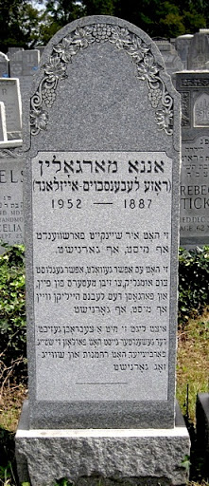

4). My Ancestors Speak

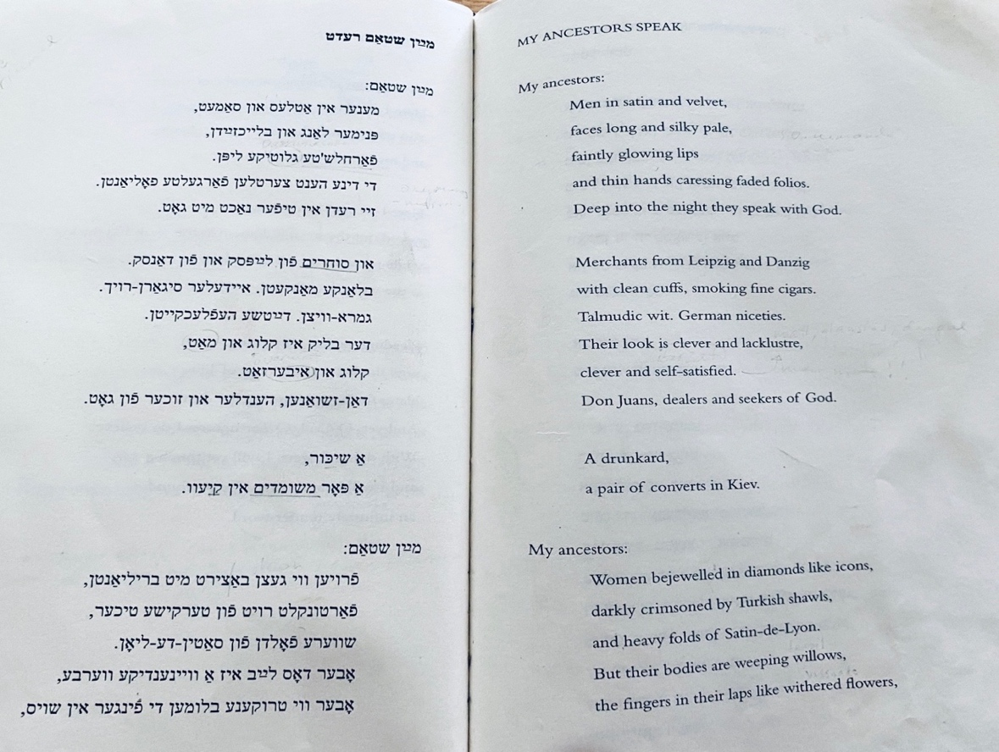

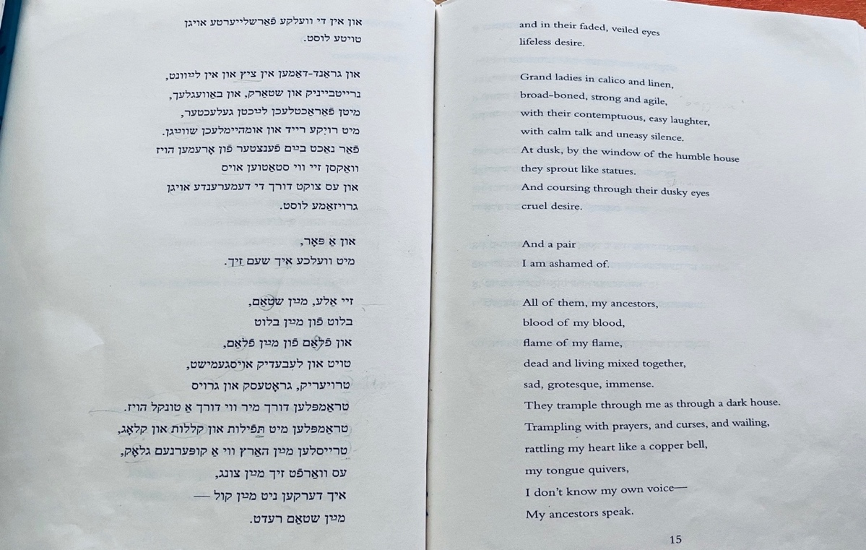

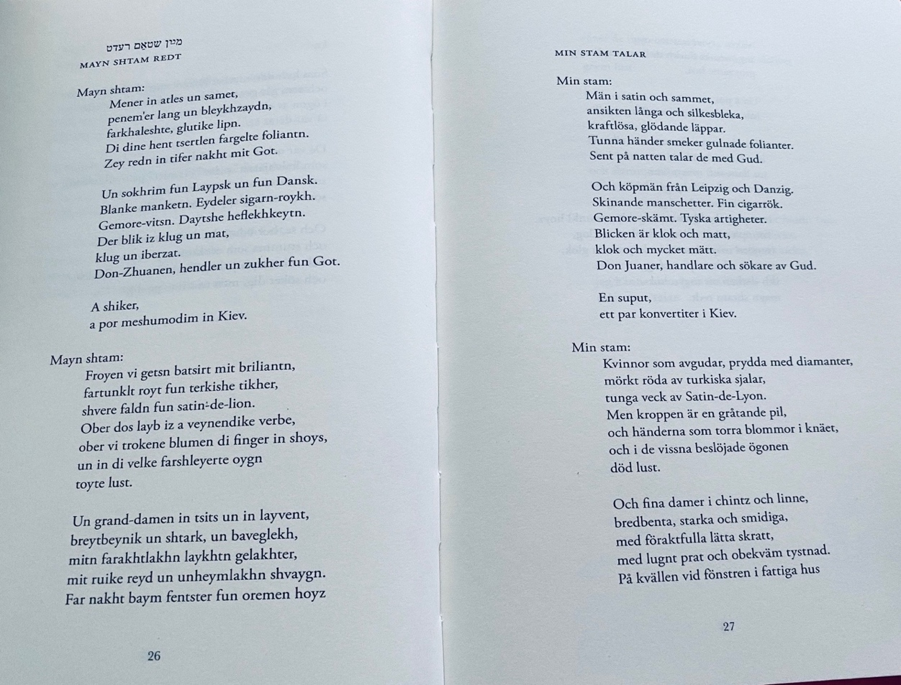

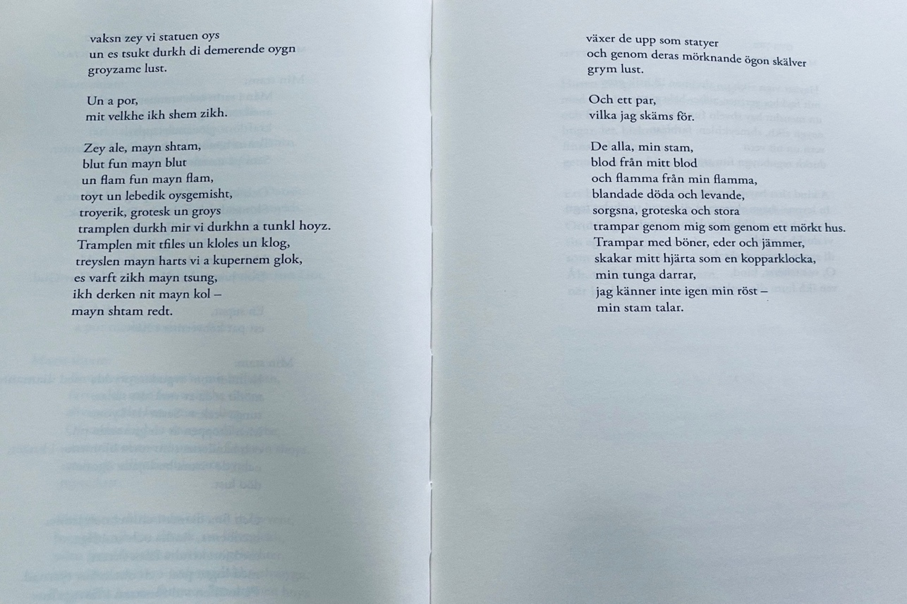

Fragment:

My Tribe Speak

All of them—my tribe,
blood of my blood
flame of my flame,
the dead and the living mixed;
sad, grotesque, large,
they tramp through me as through a dark house,
tramp with prayers and curses and laments.
They shake my heart like a copper bell,
my tongue quivering.
I don’t recognize my own voice—
my tribe speaks.
(…)

Excerpt taken from the dedication to the book by
Feldman, Deborah, Exodus: A Memoir . Penguin Publishing Group. 2014

5). Maria

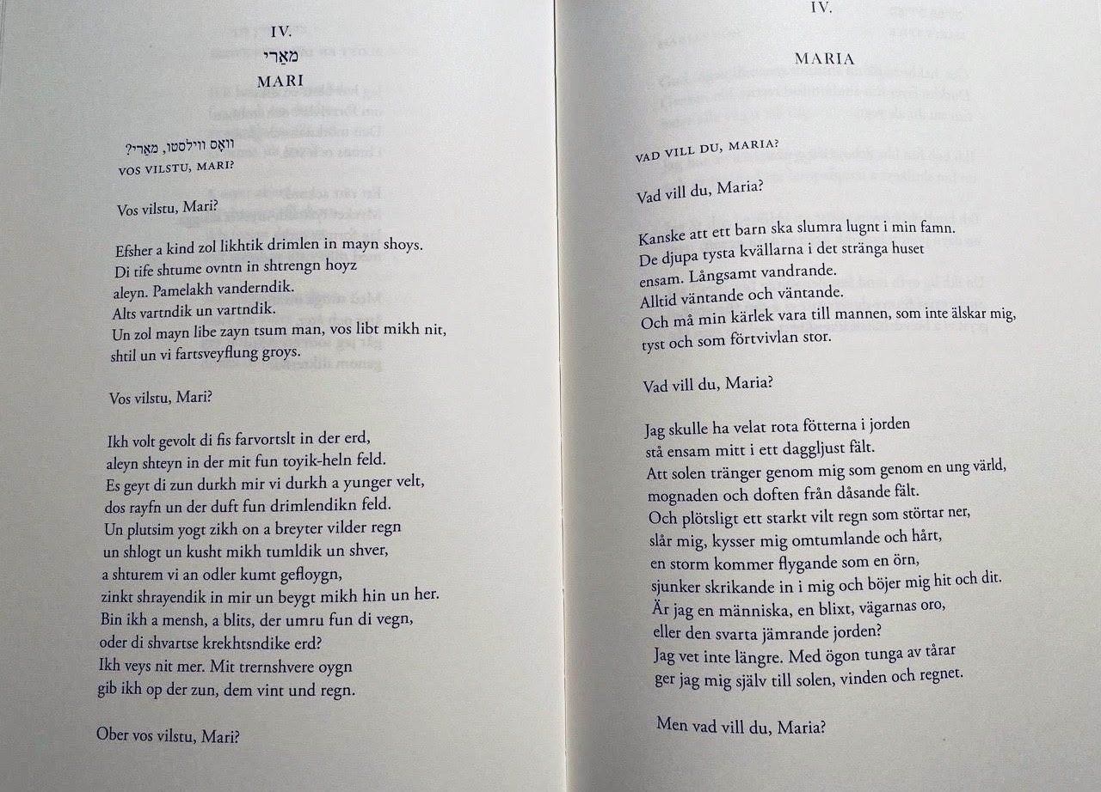

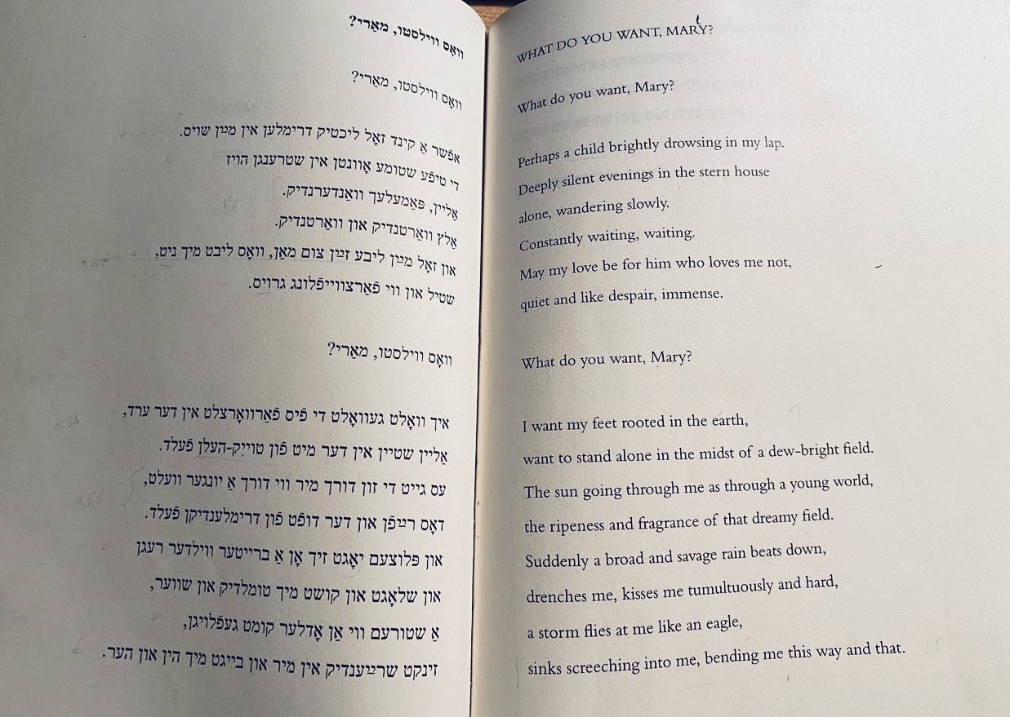

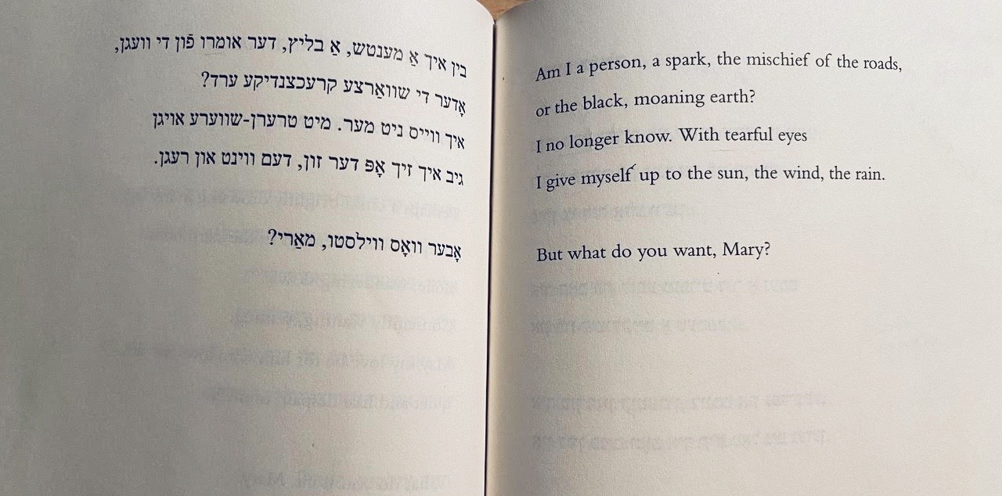

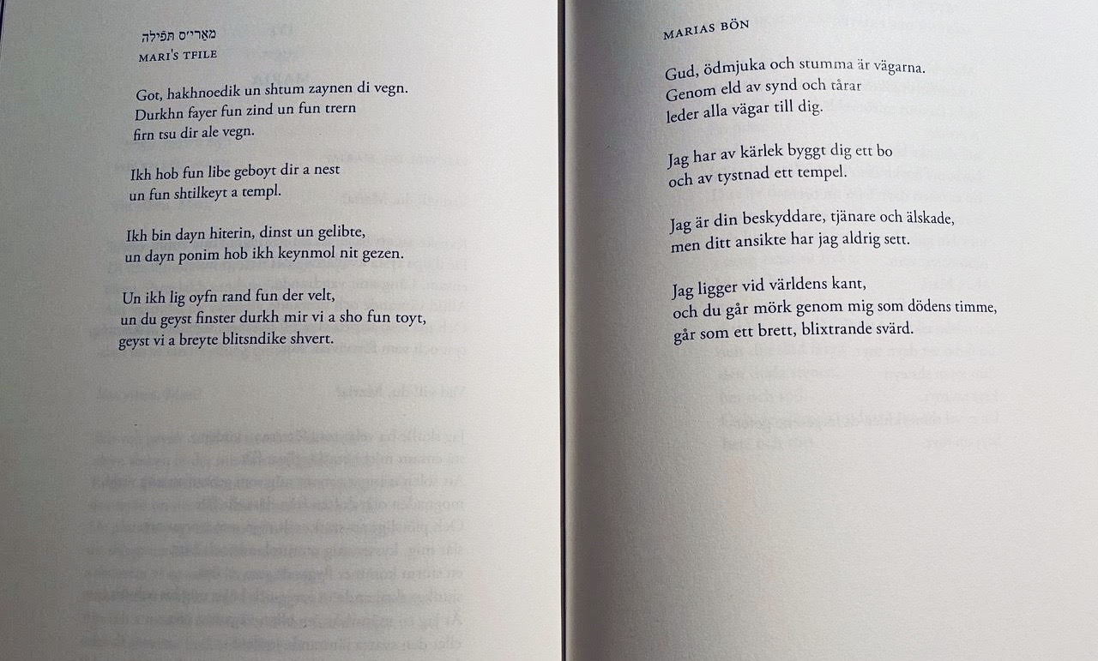

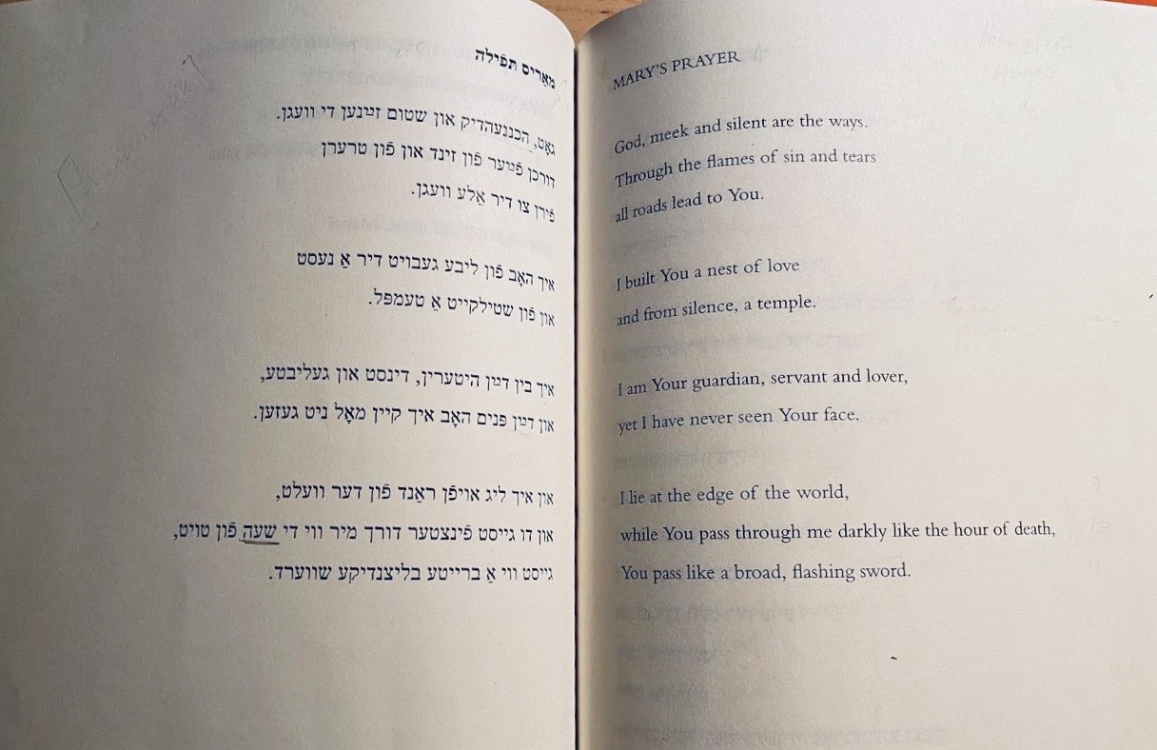

Bibliography:

https://yiddishkayt.org/view/anna-margolin/

https://www.tupeloquarterly.com/4-poems-by-anna-margolin-translated-by-maia-evrona/

https://intranslation.brooklynrail.org/yiddish/from-lider/

